Wai-nani:
High Chiefess of Hawaii –
Her Epic Journey
by Linda Ballou
www.lindaballouauthor.com
lballou6@sbcglobal.net
818-506-0093

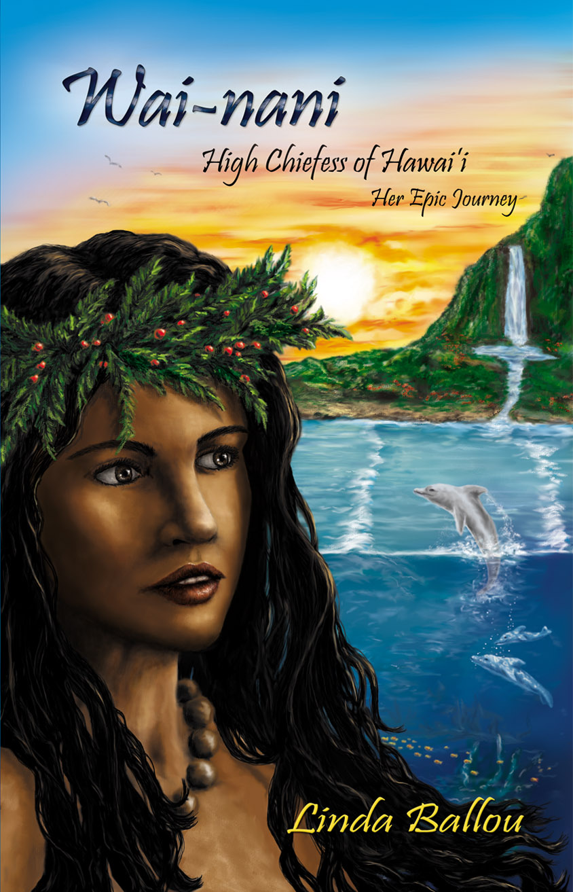

1
Dolphin Dance

The red apple of the ohi'a tree tasted sweet in my mouth as I watched the drifting plumes of Pele, Goddess of the Volcano, cast shadows upon the shimmering sea. Frothy surf reached my ankles then receded, leaving tiny bubbles of foam upon a blank tablet of sand. The crescent sail of an outrigger flared upon the horizon. The ancestors who lived in the long-long ago sailed here in canoes like this, bringing pigs, dogs, bananas, breadfruit and the gods with them. Just beyond the arcing swells, I spied my dolphin friend, Eku. His playmate Laka’s dorsal fin cut through the clear water in the opposite direction of his as they dallied away the day in their dance of secret yearnings.
My hair felt hot and heavy on my shoulders. I longed to feel it floating free in the sparkling sea. I untied the knot of my pa'u and let it fall to the ground. Splashing through the shallows, I dove under a cresting wave. Once on the other side of the breakers, stretching arms and legs to maximum stroke, I swam to Eku. The crystalline water soothed and cooled me as it swirled through my mind in gentle rivers.
Halfway to Eku, I called out to him in his squeaky tongue. He would have to come quickly to protect me from Laka, his jealous lover. I had named her after the Goddess of Dance because of her graceful, swift movements. Once, long ago, she rammed me hard in the belly with her rubbery beak. Eku had to stop her before I drowned. I always noticed when Laka was near.
I swam fast to get to Eku. His dorsal fin sliced the water as he came toward me, then his sleek body rose out of the water as he picked up speed. Laka was close behind. When Eku reached me, he circled about then rolled over on his back so that I could rub his tender belly. He loved this greeting and giggled when I massaged his underside. There was much squeaking and head bobbing from Laka as she circled about us, but she did not come near. I reached around Eku’s body, draping myself around his mottled frame. His skin trembled at my touch. We rolled to and fro in the heave of the deep blue swells.
I grabbed hold of Eku’s ragged fin, aligning myself on his right side. Laka took her regular position on his left. He let out a long, low whistle signaling us forward. We churned through the clear water, creating a wake in our path. I kept my head above water where I saw bubbles and brilliant blue sky, while he maintained a stable level so that I could breathe. Laka stayed with us, knowing exactly which direction he would turn, how slow and how fast he would go, without a sound from Eku.
I feared nothing, not even Mano the shark, when I was with Eku. His round soft eyes and constant smile spoke of kindness. His strong body moved with grace at exhilarating speeds. I felt at rest and safe with him. I wondered if I would ever meet a man with Eku’s strength, tenderness and loyalty. Could I feel this joy with a man? As we skimmed across the blue mountains of water, these thoughts trailed out behind me.
When I returned to my family’s houses that night, my mother was tapping her mallet on a carved wooden block used to stain a design onto kapa. This was the work of maka'ainana, but she loved to create her own designs and scent the cloth for her many dresses with the perfumes of fragrant plants. The smell of the fish wrapped in luau leaves steaming in the ground oven reminded me that I was hungry.
“Oh Wai-nani, my wandering wahine, has come home in time to eat, but not in time to help her mother,” she said without lifting her head from her labors. Her dress, tied at her shoulder, was stained with the colors of a lavender sunset. She wore a lei po'o of braided coconut fibers to hold in place a thick shock of black hair laced with silver streaks. Once renowned for her beauty, my mother was no longer lithe and athletic, but her glittering orange-almond eyes held many secrets, and she remained my father’s favorite wife.
“I’m sorry.” Inwardly I grumbled as I watched our servant fill the koa bowls full of rich purple poi to be delivered to my father, my brother and the other young warriors of our village in the men’s eating house.
“Why is it forbidden for me to eat with my brother? We swim, wrestle, and fish together but when the evening sun sets, I am no longer welcome in the company of the boys of our village.”
“Men face great dangers; they carry war sticks to keep peace, snare birds and fish so you may eat. You don’t want to do these things,” she said, impatient with my protests.
“This is not a good answer,” I said.
“You are the blossom from the topmost branch with beauty unsurpassed. It is time you put away childish pleasures and follow the royal path.”
She held out a slim hand and beckoned me to come to her. I settled down beside her.
As she combed tangles from my hair that smelled of salt from the sea, and massaged pungent ginger oil into it, she tried again to answer my question.
“Many things that come to us from the ancients we don’t question. In the beginning, Wakea, the God of Light and the Heavens, married Papa, the Goddess of Earth. From this great love came a daughter, the Heavenly One Who Made the Stars. She was so beautiful that Wakea could not resist the sweet smell of her skin and the dance of the sun in her eyes. He schemed night and day to have his daughter without Papa knowing and becoming jealous. His kahunas smashed the head of a black pig and read the entrails to find the solution.”
As she talked story and stroked my hair to a lustrous shine, her aloha for me softened my questioning heart.
“‘Build eating houses separate for men and women. Tell Papa that this is the will of the gods. This way you will always know where she is and can know your daughter’s great charm without discovery,’ the kahuna advised.
“Wakea thought well of this plan. He made it kapu for men and women to eat together and set aside tabu nights of separate sleeping. He lay down with his dazzling daughter of the heavens. From their coupling came the birth of the islands of Molakai and Lanai.”
“Do you believe this story?” I asked.
I felt a sharp tug on my scalp. “It is the way of our people,” she said, putting an end to our talk.
I left her and went into the velvet night to ask the winking stars my question. But, no answer came. I crept into the shadows cast by the walls of the men’s hale, peered through the thatching and eavesdropped on their talk. Their bowls of poi were empty, and they sat talking of the day and drinking 'awa. Much of the drink from the bitter root was shared as they laughed and challenged one another to sport. The day had been spent wrestling. Soon it would be time for the festival of makahiki, and their contests would begin in earnest. They had to be fit to win these mock battles. Death or injury could easily come to the warrior who was not swift and daring.
“Will you be in the wave-sliding contest tomorrow?” my younger brother Mimo asked Kali as he swilled another cup of 'awa. “Today was a sorry day for you in wrestling, but no one can beat you on the olo board.”
“That’s true. No one can beat me in the water. I am the most powerful of all the swimmers on Maui.”
“So you say,” said my brother. “I place a wager on Maka. We will see who is the richer at the end of the day.” He took the shark tooth necklace from his chest and held it up so his friend Maka could see the strength of his bet. I left the hale saddened that I was not allowed to meet my brother’s challenge. I knew I could wave-slide as well as any of them, if not better.
The next day found Maka and Kali floating belly down on boards that weighed as much as me and were twice my height. They rested behind the curl of cresting waves that came in sets of seven and waited patiently in the midday sun for the right wave. A crowd gathered on the shore. Mimo stood among the villagers, waiting for the match to begin.
I whistled to Eku, signaling him to come to me in the quiet cove out of sight of the others. Soon, he and Laka arrived. He let me place a vine noose about his nose while I tried to stand on his slippery back. I couldn’t keep my balance in even a small wave surge. I slid from side to side and grabbed hold of his dorsal fin for balance. Puzzled at my antics, Laka squealed in high-pitched cries as I kept trying to stand up on Eku’s back. Eku called to her in an eerie, shrill voice. She came up to his side, close enough for me to place one foot on her back and one on his. I rose from a crouched position and steadied myself with my rope. It worked! Soon, we were riding the white-backed waves together.
Eku, Laka and I came around the long finger of the rock jetty and got into position with the other wave-sliders. Maka saw me out of the corner of his eye, but too late to stop me. A great wall of water forming behind us lifted, heaved forward, and broke over the top of us. I caught the movement with Eku, who found the perfect balancing place to take us to the base of the foaming green giant shot through with sunshine. As we slid across the wave, I rose and stood in the tube of luminous water. With one foot planted on Eku, the other on Laka, I rode the great white bearded one and felt the power of the sea churning beneath me. Dazzling light shafts penetrated the wall of the wave, creating a continuous rainbow. I became a sea goddess riding the comet as it streaks through the starry sky—free of all manner of human weakness, free of all kapus, graceful, filled with divine mana.
When my ride ended, I could see that Maka and Kali had both fallen from their boards. I was the winner. I gave Eku a vigorous rub on his white belly and kissed Laka’s beak. Even she seemed to smile as I parted from them. I strode to the shore through the surf, eager to share my glorious adventure. The crowd murmured at my approach. My brother frowned when he realized that I was wearing his malo. It is kapu, punishable by death, to wear another warrior’s malo. The small congregation went silent. He glowered at me with burning eyes and snatched the loincloth from my body.
My budding breasts stand rigid and high, and my slim hips ride on sturdy, solid legs. Still, I felt burning humiliation in my nakedness. My father stomped across the beach wearing his shoulder cape of yellow feathers. His mood was as dark as Pele’s heart. His face was turgid, purple with rage. His hand trembled on his spear as he drove it into the sand at my feet.
“Wai-nani, what is this? Do you think you are a warrior?”
“No, Father,” I replied, meeting his fierce eyes, framed in the tattoos that curled to his forehead. “But you do not love Wai-nani as you would a son.” I cast my eyes down afraid of his rage.
I was just a keiki when I witnessed him put to death a servant girl who had come too close, letting her shadow fall upon his royal presence. A seasoned warrior, he could pull an arm out of its pocket or crush the rib cage of an enemy with his skilled hands, but something that day kept him from bashing me unmercifully or ordering my tongue removed for insolence. Instead, he turned to the villagers who had witnessed my miraculous surfing feats. Although they were in awe of my grace in the water, their fear of my father kept them silent. They fell back when he shouted,
“There will be a contest. I will place my necklace at the highest point of Nihow,” he said, pointing to the isle on the horizon. He took off his choker woven from human hair with an ivory pendant made from the whale’s tooth, and held it high for all to see. “The warrior who swims to the island and returns the necklace to me will have my daughter as his wife and become a chief.”
He turned back to me. “You will have a husband and children and honor the ways of all wahine before you.”
I was thunderstruck. I didn’t feel a woman’s love for any of the young warriors of Hana. Although I was terrified of my father’s violent nature, I looked into his murky black eyes.
“My father is a cruel chief who has lost his mana!” I said, this time holding his gaze. He stared blankly back for a few tense moments then he struck me solidly in the face with the back of his hand. The taste of blood trickling from my torn lip told me this was not a dream. The sky spun, lights whirled in the black around my head and my ringing ears were deaf to all around me. His next words sounded far away.
“The contest will begin with the new sun.” Any tenderness he once possessed for his first daughter retreated behind stony eyes.
Whirling about, I ran back into the surf. My tears tasted of blood and the sea. I dove under a pounding wave and paddled frantically out beyond the breakers. Calling out in a high-pitched whistle, I clicked my tongue furiously, trying to bring Eku to me. I made the sounds of a stick rubbing against a gourd, but the squawk of sea birds was my only reply.
The sun rose the next day, casting a crimson flare across the sky. Jagged purples kissed the horizon. Black plumes from the distant volcano rose high above white clouds. Twelve young men stood on the beach awaiting the signal from my father. In the middle of the line was Maka, my old friend who had taught me to cast nets, spear fish and throw stones from a sling. We had spent many hours diving in the cave pool where the octopus hides under the rocks. His stout, sturdy legs were bowed from birth. He smiled at me with gentle brown eyes, exposing strong white teeth. He was a fair and generous man, but I couldn’t imagine myself with him in the marriage bed.
The twins Makoa and Keha standing beside him were identical except for the jagged scar that went across Keha’s belly. Mano the shark had made him warrior when he was still a child. Makoa’s dark eyes were filled with deviltry. Given to pranks, he had once taken my pa'u while I sunned myself beside the rock pool. No passion passed from me to either of them. Boasting Kali strutted before the group and came up to me. He put his hand to his chest and said, “When the sun turns red, Wai-nani will share my mat.”
I feared his dark eyes with heavy brows that knit together, forming one line across his bold features. He had bullied and bested the others at wrestling and sport all the seasons I could remember. I recoiled at the thought of this braggart for my husband. Even though his six-foot-six-inch frame, supported by flat, firm muscles alive under his brown skin spoke of royal blood, he was fouled fruit to me.
My father arrived wearing his finest yellow feather cape and the crested helmet of an ali'i chief. He planted his spear and spoke to the warriors before him.
“There will be no wrestling, no bone breaking and no gouging. The swiftest, most agile swimmer will have my daughter, Wai-nani, for his wife.”
When he finished speaking he clasped his spear, lifted it high over his head, then dropped the tip into the sand, signaling the race to begin. My brother was among the warriors who dove into the calm sea, rippling the prism of morning sun upon the water with broad strokes. My marriage to him would produce an ali'i ruler of the highest blood caste. As I watched them swim into the horizon, I glimpsed a fin arching like a quarter moon. Untying the knot of my pa'u, I let the drape of cloth drop to my ankles. Casting a last glance over my shoulder to my father, I ran into the sea and dove under a foaming wave. My hair swirled like seaweed about my face as I kicked with strong legs, stroking hard to reach Eku.
He heard my shrill whistle and came dashing to me with Laka close behind. Excited, he circled me swiftly once then came closer so that I could rub his tender underbelly. I did, then clasped him in a rolling embrace. I reveled in his affection and acceptance. The familiar tingling I felt whenever he was near brightened my spirits. He took me on a plunging ride, lifting me completely out of the water as I clung to his dorsal fin. We flew so fast I felt the chains of my father’s edict falling from my mind. Racing from the embrace of a man I could not love, I left behind children destined to be conceived in hate and cast my fate like a fisherman’s net upon the sea.
I saw Pele, Goddess of Fire, resting on the clouds with her shining lava-black hair falling down on round shoulders. She wore a white hibiscus spiked with red on her left ear, and a blood-red kikepa tied at her shoulder. Drifting in the cloud cradle that circles the smoking cone of the volcano above her billowy bed, she dozed with her feet crossed at the ankles and her hands lying peacefully on her belly. Her full lips were parted in a wistful smile. The lids of her eyes, laced with long black lashes, were closed. I held onto Eku’s muscled neck as his great strength lifted us out of the deep with cool spray flying. I could feel the pull of Pele and prayed I would find shelter at her tumultuous breast.

